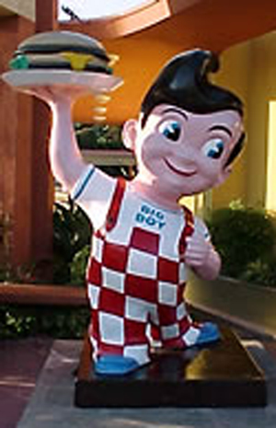
Pop Art
Once you “got” Pop, you could never see a sign the same way again. And once you thought Pop, you could never see America the same way again.
--Andy Warhol

- Pop Art was an art movement in the late _____________________________________ that reflected everyday life and common objects.
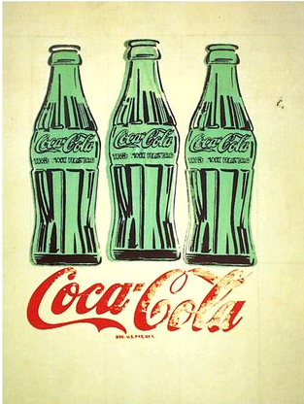
- Pop artists blurred the line between _______________________________________ and _______________________________________.
- “______________________________________________ created images that anybody walking down the street could recognize in a split second…all the great modern things that the ________________________________________________________ tried so hard not to notice at all.”—Gretchen Berg
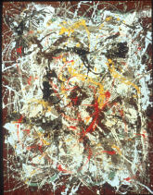
Abstract Expressionism
- The Pop artists moved away from ___________________________________________ which was the “in” style of art in the 50s.
- The Abstract Expressionist evoked emotions, feelings and ideas through formal elements such as:

  - __________________________
  - __________________________
  - __________________________
  - __________________________
  - __________________________

Pop Artists
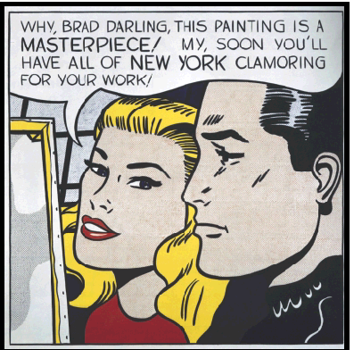
- Pop Artists used common images from everyday culture as their sources including:
  - _____________________________________________
  - _____________________________________________
  - _____________________________________________
  - _____________________________________________
  - _____________________________________________
- Pop Artists used bold, flat colors and hard edge compositions adopted from commercial designs like those found in:
  - _____________________________________________
  - _____________________________________________
  - _____________________________________________
  - _____________________________________________
- Pop Artists reflected 60’s culture by using new materials in their artworks including:
  - _____________________________________________
  - Plastics
  - _____________________________________________
  - Fluorescent and
  - Metallic colors
- As well as new technologies and _____________________________________:
  - Mass production
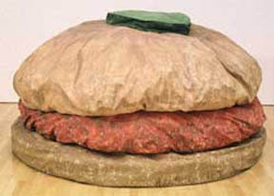
  - Fabrication
  - Photography
  - Printing
  - Serials

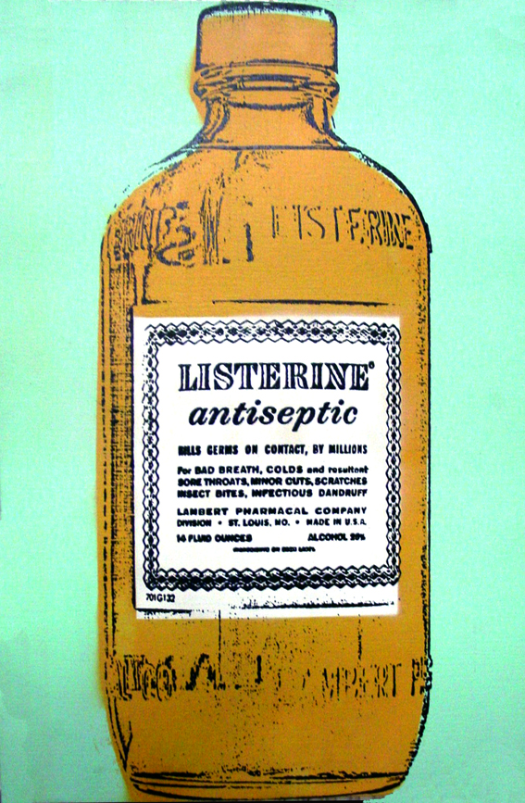
- Pop art was appealing to many viewers, while others felt it ___________________________________________ common people and their lives.
- It was hard for some people to understand why Pop Artists were painting cheap, everyday objects, when the function of art historically was to uphold and represent culture’s most valuable ideals.
Andy Warhol
- Andy Warhol was one of the most famous Pop Artists. Part of his artistic practice was using ___________________________________________________ and ______________________________________ of making art including:
  - Photographic Silk-Screening
  - ________________________________________________________
  - _________________________________________________________
  - Collaboration
  - Media events
- Warhol_______________________________________________________ (used without permission) images from magazines, newspapers, and press photos of the most popular people of his time
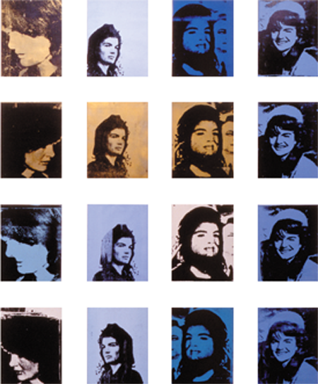
- Warhol used the ___________________________________________________of media events to critique and reframe cultural ideas through his art
- Warhol took common ________________________________________________ and gave them importance as “art” He raised questions about the nature of art.
- Pop artists stretched the definitions of ________________________________________________________ and how it can be made.
- The art world today reflects many of the ideas, methods and materials initiated by the Pop Art movement.

Keith Haring
- Keith Haring was another famous Pop Artists. He was an American artist and __________________________ whose work related to __________ _____________ street culture.
  - Heavily political work
  - ________________________________________________________
  - _________________________________________________________
  - street culture

