Downloading Photos

Follow these steps to download your photos into Adobe Bridge from your digital camera

- Using the USB cord, plug the camera into the back of your Mac (or use a card reader)

- Turn the camera on
- Open Bridge

- Choose your folder (NOT your house)

- Create a new folder for each assignment

- Click the icon ‘Get Photos from Camera…’

- Click ‘Advanced Dialog’ in the bottom left corner

- Choose a new location to save your photos.

YOUR FOLDER>PROJECT NAME

- Rename your Files: Choose “Custom Name” Your custom name should be: LASTNAME_Projectname 1. Please write Lastname_Projectname in the first box and a number 1 in the small box.

- Click “Get Photos”

- After successful download, delete your images from the camera.
Let’s make a contact sheet!

- Open Bridge
- Navigate to the file with your images i.e. YOUR FOLDER>PROJECT NAME
- Choose several images you like and want to print (command + click allows you to click several)
- Click ‘Output’ at the top right
- Choose the PDF icon
- Change your ‘Page Preset’ to U.S. Paper
- Double check under ‘Layout’ that you have 2 Columns and 2 Rows
- Click the ‘Refresh Preview’ button to see what it will look like
- Click the check mark next to ‘View PDF After Save’
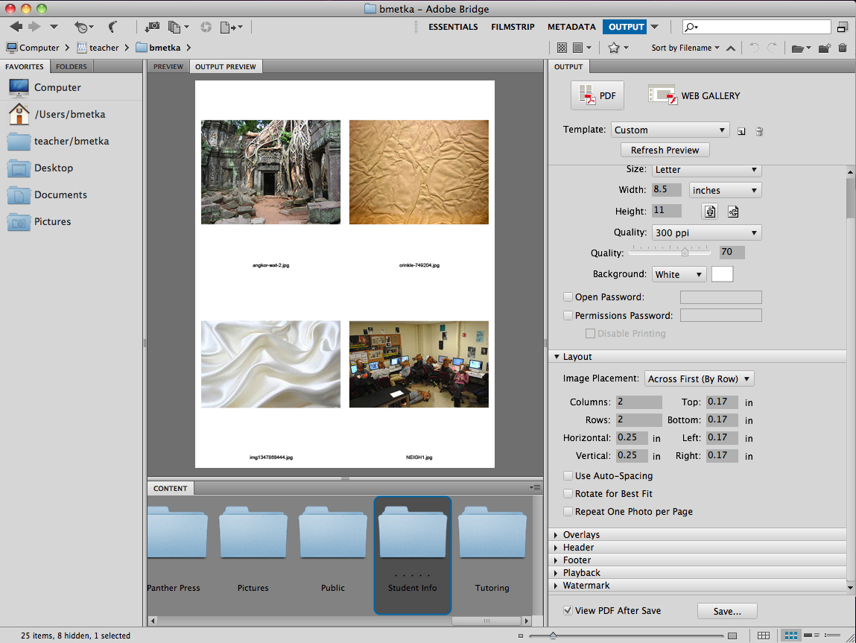
- Click Save

- Save it as Lastname_ProjectName_contact
- Navigate to YOUR FOLDER>PROJECTNAME>Save
- The file should open automatically
- Go to File>Print
- Choose the printer named 104HP3525 and PRINT!
- Write your name on it and turn it into the bin.

